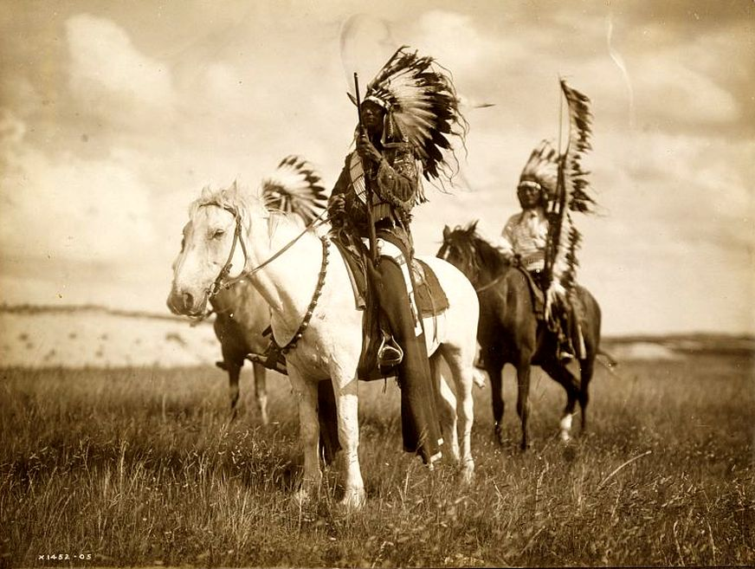
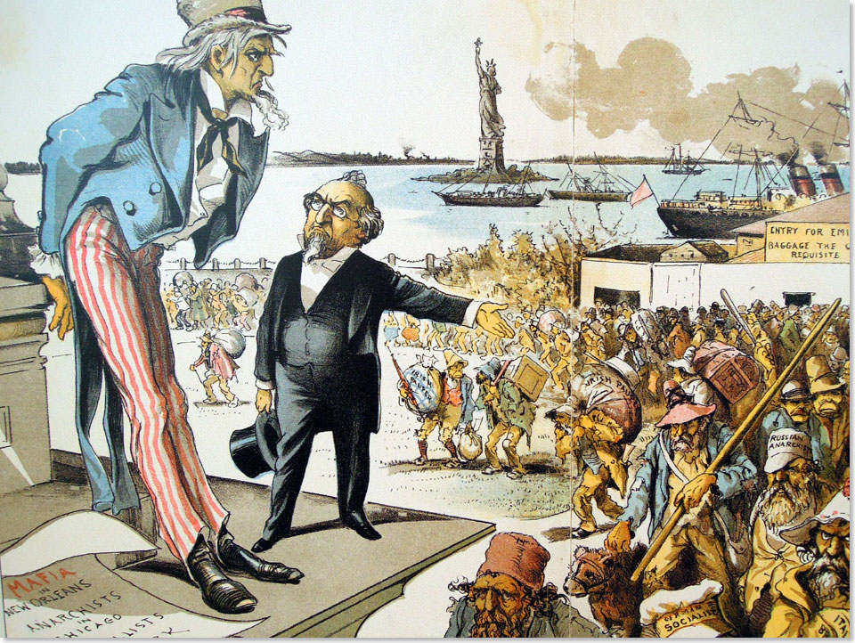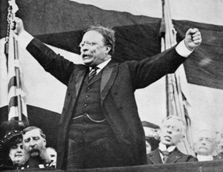

Mega Unit 1
The Great American West
The Gilded Age &
Progressivism

Date | Lesson Focus | Activities | Homework
August 27 | Welcome and Syllabus  New concept for American II |  | Paperwork!  Tissue Box
August 28 | Begin Content Unit 1  The West-  - Peopling the Land  - Competition for Land and Resources | - Introduce Primary vs. Secondary Sources  - Homestead Act and Ft Laramie Treaty | - Vocabulary  - Finish Primary Sources
August 29 | The West-  - The Indian Wars  - The Rise of Populism | - Mapping the West  - National People’s Party Platform | - Vocabulary
August 30 | The North & The Gilded Age  - The Industrial Revolution  - Robber Barons vs. Captains of Industry | - Chunking Docs Activity | - Start Gilded Age Vocab
August 31 | The North & The Gilded Age  - Immigration & Urbanization | - Finish Chunking Docs Activity  - “Undistinguished Americans” | - Gilded Age Vocab

Date | Lesson Focus | Activities | Homework
September 3 | Labor Day- No School
September 4 | The North & The Gilded Age  - The Rise of Labor Unions | - Primary Source Analysis-The Jungle  - Group Activity-Chunking of Notes | - Gilded Age Vocab
September 5 | Progressivism in the US  - Reformers and the Social Calls for Change | - Introduce Progressive Speed Dating | - Progressive Vocab
September 6 | Progressivism in the US  - Political Responses to Progressivism | - Voting Map and Elections | - Progressive Vocab
September 7 | Progressivism in the US  - Exploring issues of Child Labor, Women’s Labor and Safety in American Business | - Voting Map and Elections  - Work on Speed Dating | - Progressive Vocab

Index Card Vocab:

Front of Index Card Back of Index Card
Vocabulary Word | Internet Definition | Drawing of Vocab Term
 | Significance~ Why does it matter?

Level 1 Required Vocabulary ~ Required for all Students

The West  - Homestead Act  - Turner/Frontier Thesis  - Transcontinental Railroad  - The Long Drive  - Barbed Wire  - Fort Laramie Treaty  - Sand Creed Massacre  - Battle of Little Big Horn  - Battle of Wounded Knee  - Dawes Act | The Gilded Age  - The Gilded Age  - Robber Baron vs. Captain of Industry  - Laissez-faire  - Social Darwinism  - Labor Unions and Strikes  - Political Machines  - Immigration  - Urbanization  - Industrialization | Progressivism  - Muckraker  - 16th Amendment  - 17th Amendment  - 18th Amendment  - 19th Amendment  - Disenfranchise  - Plessy v Ferguson  - Conservation  - Preservation  - Social Gospel

Level 2 Required Vocabulary ~Required for Honors/Optional for Academic

The West  - Morrill Land Grant Act  - Populist Party  - Open Range Grazing  - Assimilation | The Gilded Age  - Bessemer Process  - Gospel of Wealth  - Yellow-Dog Contract  - Sherman Anti-Trust Act  - Pendleton Civil Service Act | Progressivism

