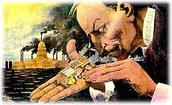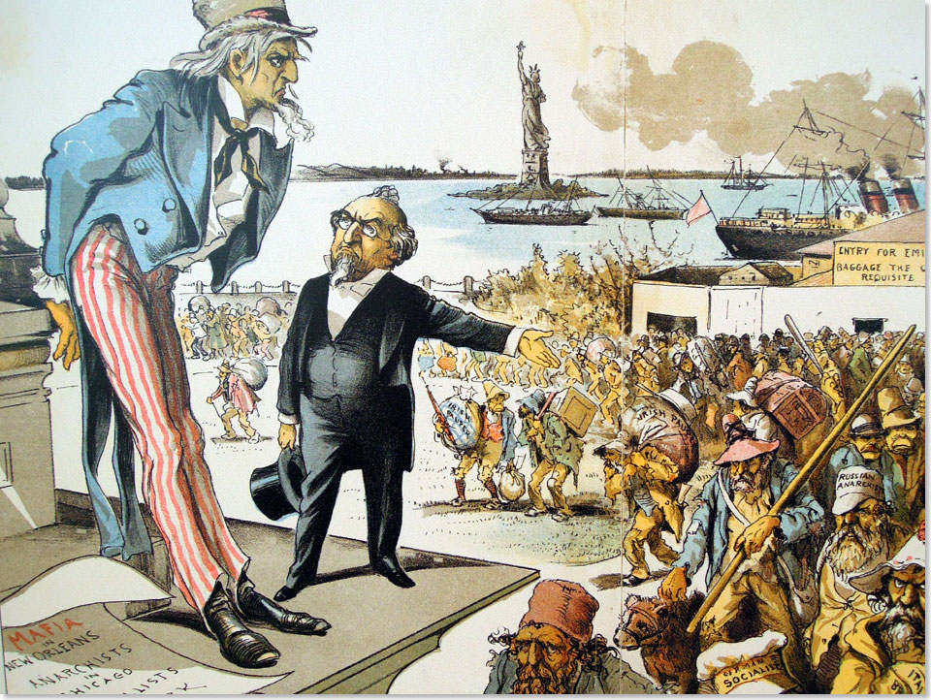
The Gilded Age
1865-1898

As the United States exits the Civil War, the country finds itself attempting to redefine itself for a modern era. The nation struggles with the legacy of slavery and the new role and expectations of the free African American population, the mass movement of people into the American west and the conflict it creates with the Native peoples of the west, and the rise of big business in the north and the influence it exerts over the American government and people. This era is a time of great change and a time of great challenges, but will help to trigger ideas of reform and a significant reexamination of the government.

Date | Lesson Focus | Homework
February 6 | Introduce The Gilded Age  - Role of Government in the era  Seating Chart!  Introduce Timeline  Start Document Analysis Activity | Unit 2 Purple Sheet  Read Chapters 13, 14 & 16 (Due by 2/14)  Start Timeline
February 7 | Analysis of Political Cartoons  Gilded Age  - Rise of Big Business: Robber Barons or Captains of Industry?  Document Analysis Activity | Unit 2 Purple Sheet  Read Chapters 13, 14 & 16  Timeline
February 8 | Gilded Age  - Industrialization and Strikes  Chart- Unions and Strikes Using Secondary and Primary Sources  Work on Document Analysis/Timeline? | Unit 2 Purple Sheet  Read Chapters 13, 14 & 16  Timeline
February 9 | Gilded Age  - Urbanization and Immigration  Document Analysis/Chart/Timeline | Unit 2 Purple Sheet  Read Chapters 13, 14 & 16  Timeline
February 10 | Shaver Out  History Alive Activity- Chinese Immigration  Early Release | Unit 2 Purple Sheet  Read Chapters 13, 14 & 16  Timeline

Date | Lesson Focus | Homework
February 13 | Gilded Age- Wrap Up  Review for Test | Study  All Work Due Tomorrow
February 14 | West and Gilded Age Test  Introduce Progressivism
February 15 | Start Progressive Unit

Expected Assignments Due on 2/14:

- Gilded Age Document Analysis
- Timeline
- Unions and Strikes Chart
- Chinese Immigration Activity
- Purple Sheet

