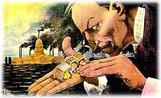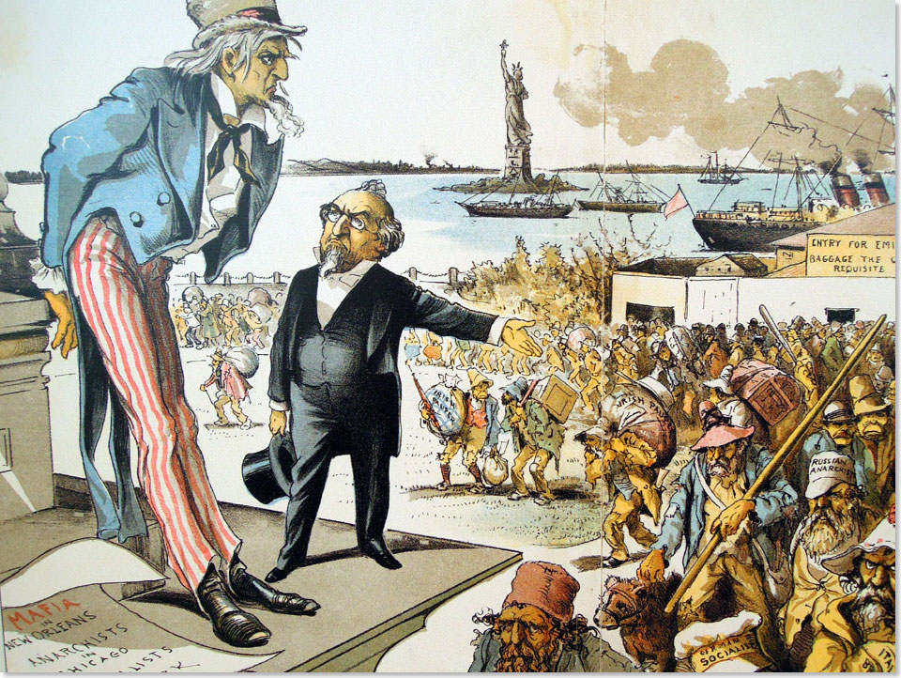
The Gilded Age
1865-1898

As the United States exits the Civil War, the country finds itself attempting to redefine itself for a modern era. The nation struggles with the legacy of slavery and the new role and expectations of the free African American population, the mass movement of people into the American west and the conflict it creates with the Native peoples of the west, and the rise of big business in the north and the influence it exerts over the American government and people. This era is a time of great change and a time of great challenges, but will help to trigger ideas of reform and a significant reexamination of the government.

Date | Lesson Focus | Homework
February 6 | Introduce the Gilded Age  - The “umbrella” of issues  Introduce Timeline  - Compare and Contrast Reconstruction, the West and the Gilded Age | Unit 2 Purple Sheet  Unit 2 Essential Questions  Work on Timeline Elements
February 7 | Analysis of Political Cartoons  - Role of Government in the Era  - Laissez Faire and Political Corruption  Time for Timeline | Unit 2 Purple Sheet  Unit 2 Essential Questions  Work on Timeline Elements
February 8 | 7 Word Summary: Gospel of Wealth  Gilded Age  - Rise of Big Business: Robber Barons or Captains of Industry?  Timeline | Unit 2 Purple Sheet  Unit 2 Essential Questions  Work on Timeline Elements
February 9 | Primary Source Analysis: The Jungle  Gilded Age  - Industrialization and Strikes  Finish Timeline  Early Release | Unit 2 Purple Sheet  Unit 2 Essential Questions  Work on Timeline Elements

Date | Lesson Focus | Homework
September 11 | Gilded Age  - Finish Industrialization and Strikes  Immigration and Urbanization Group Gallery Walk | Unit 2 Purple Sheet  Unit 2 Essential Questions  Work on Timeline Elements
September 12 | Gilded Age  - Immigration  History Alive- Immigration Activity  Timeline | Unit 2 Purple Sheet  Unit 2 Essential Questions  Keep up with timeline
September 13 | Gilded Age  - Urbanization  Document Analysis- Experiences of Immigrants  Finish TCI  Timeline | Unit 2 Purple Sheet  Unit 2 Essential Questions  Keep up with timeline
September 14 | Wrap up the Gilded Age  Review Units 1 and 2 | All work for unit due tomorrow
September 15 | Test: Units 1 and 2  Video: The Men Who Made America | No Homework!

Expected Assignments Due on 2/14:

- Gilded Age Document Analysis- Gallery Walk
- Timeline
- Chinese Immigration Activity
- Purple Sheet and Essential Questions
- Analysis of Unit Primary Sources

