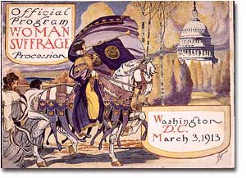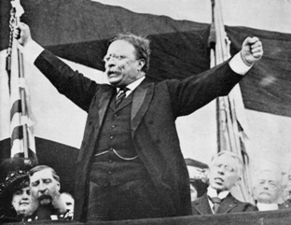
Unit 3: The Progressive Era
1898-1920

While the Gilded Age challenged the function of the American government, dealt with immigration, urbanization and industrialization, individuals began to emerge who challenged the status quo and encourage the government to become more involved.

Date | Lesson Focus | Homework
February 17 | Introduce the Umbrella of Progressivism  Muckrakers and Reformers  Introduce Progressive Speed Dating Activity | Read Chapter 17  Purple Sheet  Work on Speed Dating

Date | Lesson Focus | Homework
February 20 | American Progressivism  - Child Labor  - African Americans and the fight for Civil Rights  Document Analysis | Continue work on:  Read Chapter 17  Purple Sheet  Work on Speed Dating
February 21 | American Progressivism  - The Progressive Presidents | Continue work on:  Read Chapter 17  Purple Sheet  Work on Speed Dating
February 22 | Review Day! | Study for Benchmark
February 23 | Social Studies Benchmark  Primary Source Analysis | Study for Benchmark
February 24 | Shaver Out  - Immigration Activity  - Power Hour- Time to work on Digital Project | Digital Project Due 3/3

Date | Lesson Focus | Homework
February 27 | Shaver Out  Progressivism Activity  Time to work on | Purple sheet due tomorrow  Speed Date tomorrow
February 28 | Finish Progressivism  Progressive Speed Dating

