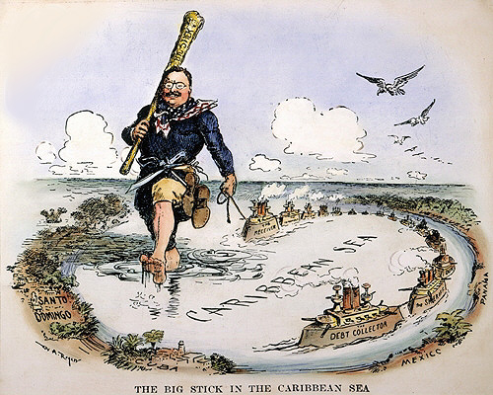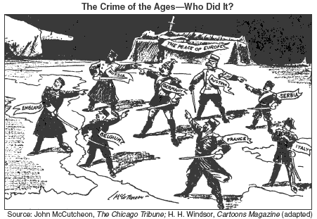
Unit 4: Imperialism and World War I
1898-1920

Date | Lesson Focus | Homework
March 6 | Introduce Imperialism  Types of Imperialism and Reasons for Imperialism | Continue With:  - Read Chapters: 18 & 19  - Purple Sheet  - Spanish American War TCI Activity  - Imperialism Map  - WWI TCI Activity  - Movie Notes  - Areas of Imperialism Graphic Organizer
March 7 | The Spanish American War  - Causes and Events of the War  - TCI Activity
March 8 | Outcomes of the Spanish American War  - Finish TCI Activity  Comparing Progressive and Imperial Presidencies
March 9 | The Causes of World War I  World War I
March 10 | The Events of World War I  WWI TCI Activity

Date | Lesson Focus | Homework
March 13 | Finish World War I  Domestic and Foreign Policy Outcomes of World War I  Finish any work that needs finishing | All Unit Work Due tomorrow
March 14 | Test on Progressivism/Imperialism/WWI | All Work Due

