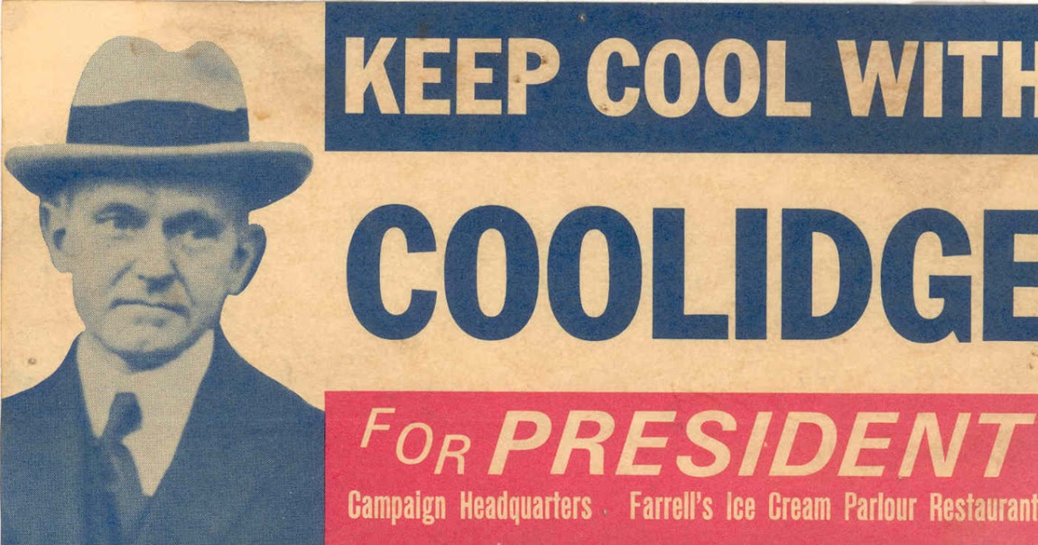
Unit 5A: The 1920s

Date | Lesson Focus | Homework/Contract Elements
October 28 | Introduce the 1920s  - Politics and Immigration  - Immigration Data Chart | - Read Chapters: 20  - Purple Sheet

Date | Lesson Focus | Homework
Monday  October 31 | 1920s  - Finish Immigration  - Foreign Policy  - Return of Nativism  KKK and Sacco and Vanzetti Article | Continue With:  - Read Chapters:  - Purple Sheet  - Immigration Data Chart (annotated)  - KKK and Sacco and Vanzetti Article  - 1920s Slang Activity  - TCI Harlem Renaissance  **All work due Friday November 4**
November 1 | 1920s Culture  - Prohibition  - Rise of Flappers  1920s Slang Activity
November 2 | 1920s Culture  - Literature  - The Lost Generation  - The Harlem Renaissance  TCI Activity- Harlem Renaissance Art Forms
November 3 | 1920s and 1930s Economics  - Post War Agricultural  - Buying on Margin  - Credit
November 4 | 1920s Quiz  Introduce Great Depression  Prepare for Next Week (Shaver out 11/7-11/10)

Date | Topic/Question | Response
October 28 | How did World War I change America?  - Social?  - Political?  - Economic?
October 31
November 1
November 2
November 3
November 4

