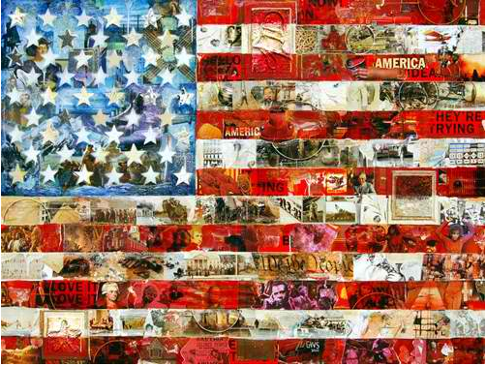

American II
Digital Interactive Curation Project

General Project Overview

Purpose:
Students will curate an online museum with exhibits from each unit of study in American II. Students will have the opportunity to choose a topic and show their topic’s changes and continuity throughout our history while we work through the broader ideas in our semester together.

Logistics:
Each student, partner set, or group of 3 will create and maintain a website through Weebly. Students will be provided with instruction on the project and the use of Weebly in class, but will also be expected to spend out of class time researching, compiling and analyzing the aspects of their project as well as the research of their classmates.

Possible Topics:
The following topics are some of the possible options for students, however a student/group is free to explore another theme if they choose, pending teacher approval.

Women | Music | Immigration
African-Americans | Native-Americans | Sports
Hispanic-Americans | Religious Minorities | Big Business
Religion | War | Foreign Policy
Art | Fashion | Supreme Court
American Cities | Entertainment | The American Presidency
Farming | Nativism | Technology

Period 1 Directions
1865-1898

- Monday February 13
- You will be going to the Media Center to learn about:
  - MLA Formatting
  - How to search
  - How to navigate Weebly
  - HSHS Library Resources
- Decide if you wish to work alone, with a partner, or small group
  - You will have time to begin to set up your site together and explore Weebly, however you will not be able to begin your topic until tomorrow in class
  - You may choose what you wish for your website address, but may not use your last names
- Choose a topic of study and sign up for it with your teacher
  - Rank your desired topics 1-3
  - Each topic will be limited to no more than 2 groups
  - Be prepared to be asked to take your #2 or #3
- Topics will be chosen via a class “draft” tomorrow 2/14

- There will be at least 4 units of study, where you will look at your topic within an era.

- For this unit of study, students will work to compile each of the following elements into their website:

Individual Requirements | Partner Requirements | Small Group Requirements
Homepage | Homepage | Homepage
2 Primary Source Excerpts | 4 Primary Source Excerpts | 5 Primary Source Excerpts
Analysis of Primary Sources | Analysis of Primary Sources | Analysis of Primary Sources
3 Photographs | 5 Photographs | 6 Photographs
Analysis of Photographs | Analysis of Photographs | Analysis of Photographs
Bibliography- MLA Formatting | Bibliography- MLA Formatting | Bibliography- MLA Formatting

Specific Element Instructions:
- Homepage:
  - You will need a central photograph that is your favorite from the entire project. You may change it as you progress
  - Write an introduction. It must include:
    - What your topic is
    - Why did you/your group choose it?
    - What do you/your group hope to learn?
- Primary Source Selections:
  - The primary sources should be excerpts, or presented in its entirety
    - They can include, but are not limited to:
      - Newspaper articles
      - Letters
      - Government Documents
      - Diary Entries
  - These primary sources should be chosen to specifically demonstrate your topic’s significance in the era.
    - It must be sourced using MLA format in your bibliography
- Photographs
  - You must find the correct number of photographs that were taken inside of the era
- For each primary source & photograph you must include analysis of the source that should be a minimum of 3 sentences each. It can address:
  - Why was the picture taken? Why is it significant?
  - What is learned from it?
  - How do these elements explain the history/relevance of your topic?
  - How do they fit into the timeline and history we have learned?
  - What surprises the student about the information learned
  - Other thoughts?

When you are finished with the unit:
- You must PUBLISH it and fill out the Google Form on my website (www.shaveramii.weebly.com). When you submit this Google Form you are essentially “turning the assignment in” and letting me know it is ready to be graded. If you submit your assignment late, you must also fill out this Google Form.

Unit 1 Due Date:
March 3, 2017

