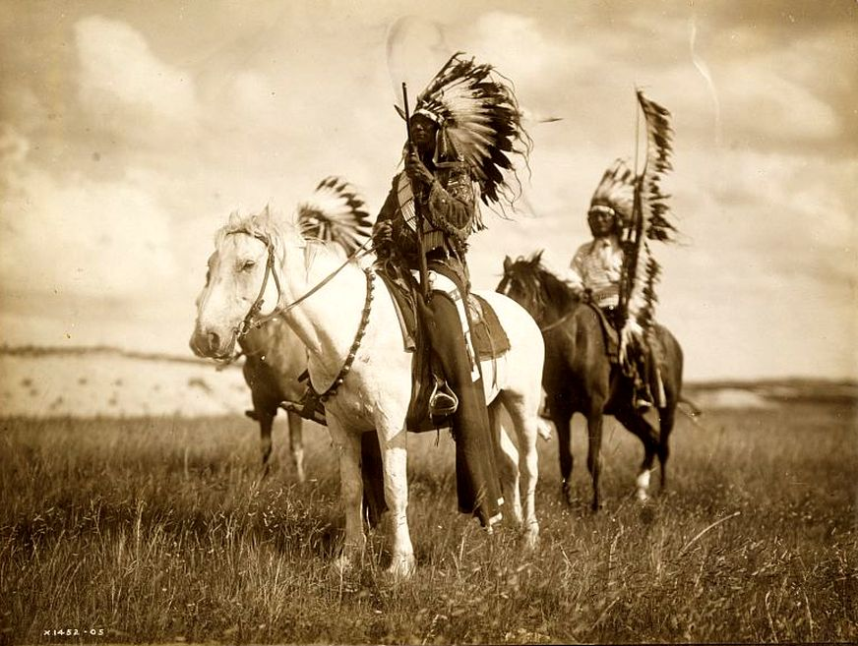
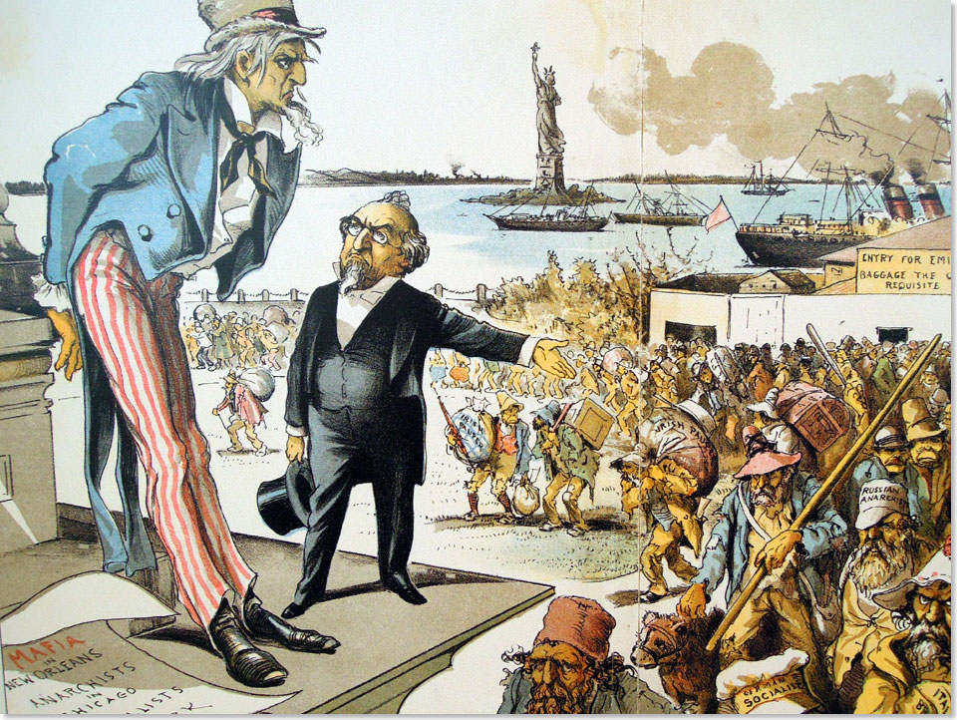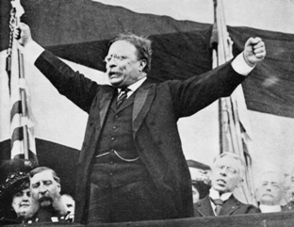

Mega Unit 1  The Great American West  The Gilded Age &  Progressivism | Week At A Glance #1  January 23-25

Date | Lesson Focus | Activities | Homework
January 22 | Welcome and Syllabus  New concept for American II | - Introductions | Paperwork!  Tissue Box
Vocabulary:
- Honors: 4-5 per night
- Academic: 3-4 per night
January 23 | Begin Content Unit 1  The West-  - Peopling the Land  - Competition for Land and Resources | - Homestead Act 7 Word Summary  - TCI: Change and Conflict in the American West | - Vocabulary
January 24 | The West-  - Peopling the Land  - Competition for Land and Resources | - TCI: Change and Conflict in the American West | - Vocabulary
January 25 | The West-  - The Indian Wars | - Fort Laramie Treaty | - Vocabulary Due

Due on Friday January 25th:
- Vocabulary
- TCI Activity- Change and Conflict in the American West
- Homestead Act
- Openings

Index Card Vocab:

Front of Index Card Back of Index Card
Vocabulary Word | Internet Definition | Drawing of Vocab Term
 | Significance~ Why does it matter?

Level 1 Required Vocabulary ~ Required for all Students

The West
- Homestead Act
- Turner/Frontier Thesis
- Transcontinental Railroad
- The Long Drive
- Barbed Wire
- Fort Laramie Treaty
- Sand Creed Massacre
- Battle of Little Big Horn
- Battle of Wounded Knee
- Dawes Act

Level 2 Required Vocabulary ~Required for Honors/Optional for Academic

The West
- Morrill Land Grant Act
- Populist Party
- Open Range Grazing
- Assimilation

Openings~ January 22-25

January 22
January 23
January 24
January 25

