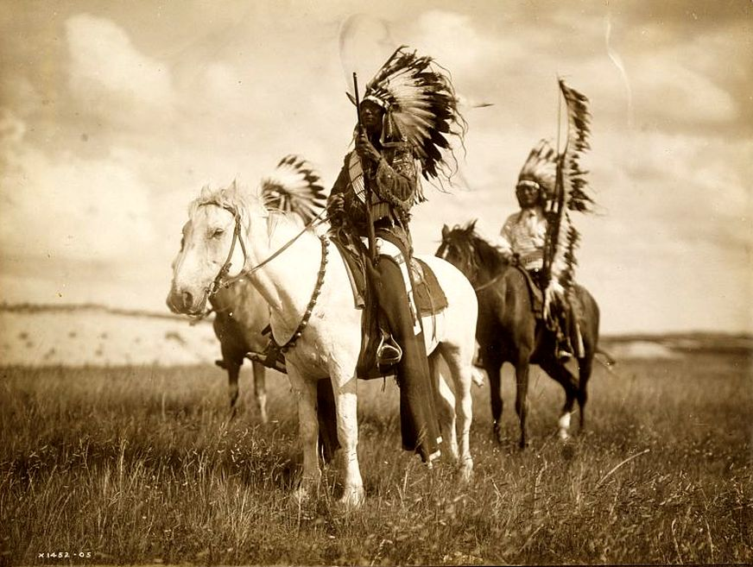
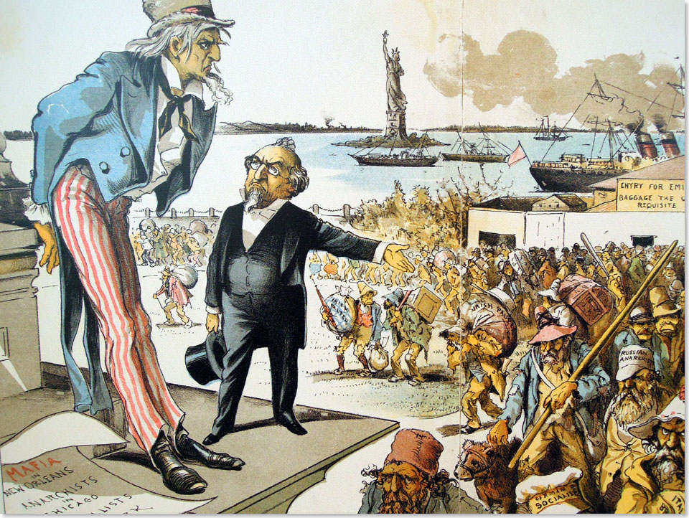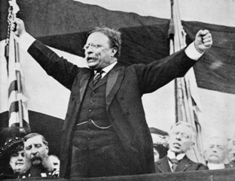

Mega Unit 1  The Great American West  The Gilded Age &  Progressivism | Week At A Glance #2  January 28-February 1

Date | Lesson Focus | Activities | Homework
January 28 | The West  - Indian Wars | Analysis of Battle or Massacre at Wounded Knee | Vocabulary:  - Honors: 2 per night  - Academic: 1-2 per night
January 29 | The West  - Finish the Indian Wars  - Populism | Finish the Analysis of Wounded Knee | Vocabulary
January 30 | The West  - Populism  - Oklahoma Land Rush | - Populist Platform  - Video Clip: Far and Away | - Vocabulary  - Finish Analysis of Wounded Knee if necessary
January 31 | The North & The Gilded Age  - The Industrial Revolution  - Robber Barons vs. Captains of Industry | - Introduce Value Timeline Activity | - Vocabulary
February 1 | The North & The Gilded Age  - The Industrial Revolution  - Robber Barons vs. Captains of Industry | - Primary Source Analysis- Robber Baron or Captain of Industry  - Value Timeline | - Vocabulary Due

Due on Friday February 1:

- Vocabulary
- Openings
- Analysis of Wounded Knee
- Annotation of Populist Platform

Index Card Vocab:

Front of Index Card Back of Index Card
Vocabulary Word | Internet Definition | Drawing of Vocab Term
 | Significance~ Why does it matter?

Level 1 Required Vocabulary ~ Required for all Students

The Gilded Age
- The Gilded Age
- Robber Baron vs. Captain of Industry
- Laissez-faire
- Social Darwinism
- Labor Unions and Strikes

Level 2 Required Vocabulary ~Required for Honors/Optional for Academic

The Gilded Age
- Bessemer Process
- Gospel of Wealth

Openings~ Jan 28- Feb 1

January 28
January 29
January 30
January 31
February 1

