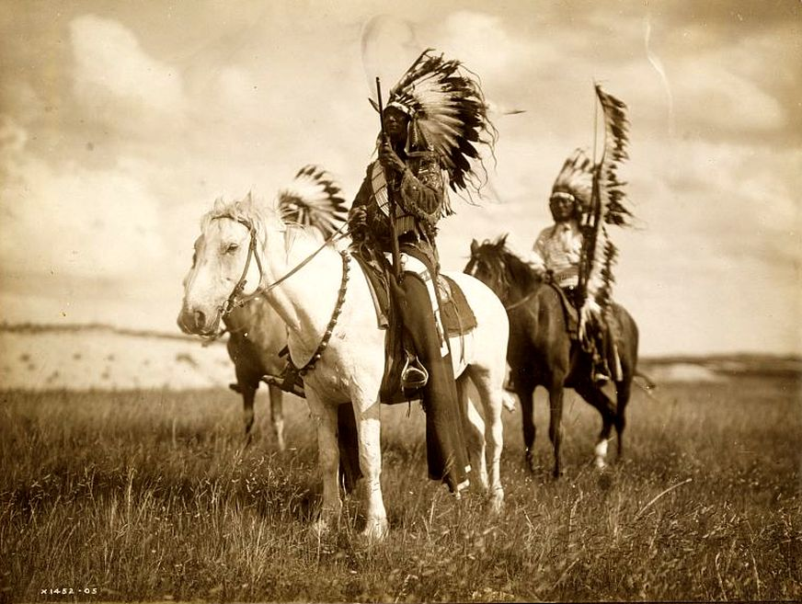
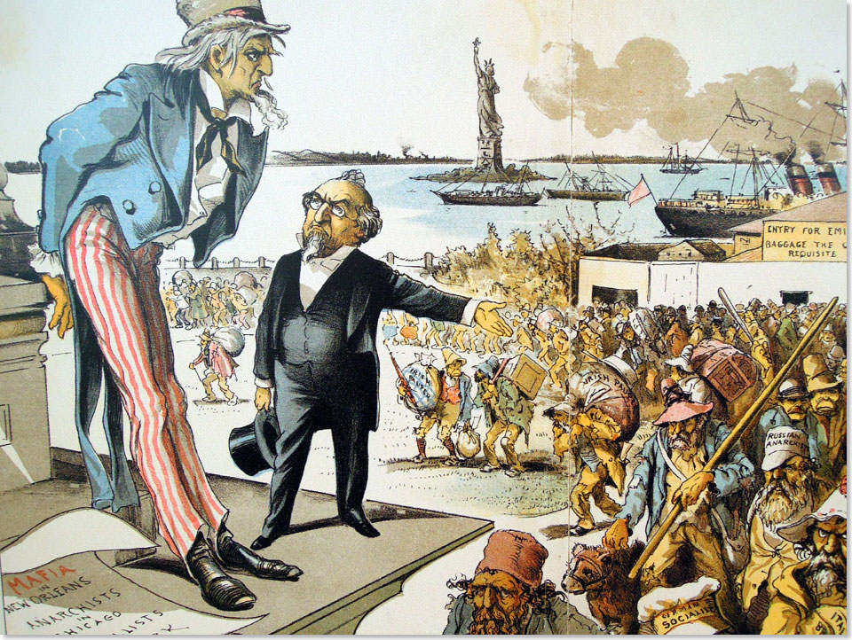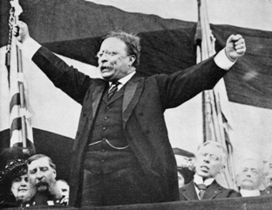

Mega Unit 1  The Great American West  The Gilded Age &  Progressivism | Week At A Glance #3  February 4-8

Date | Lesson Focus | Activities | Homework
February 4 | The North & The Gilded Age  - The Industrial Revolution  - Robber Barons vs. Captains of Industry | - Primary Source Analysis- Robber Baron or Captain of Industry  - Value Timeline | Vocabulary:  - Honors: 2 per night  - Academic: 1-2 per night
February 5 | Gilded Age and West Vocab Quiz  The North & The Gilded Age  - Immigration | - Primary Source Analysis- Robber Baron or Captain of Industry  - Value Timeline | Vocabulary
February 6 | The North & The Gilded Age  - Labor and Strikes  - Business Practices | - Primary Source Analysis- Robber Baron or Captain of Industry  - Value Timeline  - Labor Union Game | Vocabulary
February 7 | The North & The Gilded Age  - Wrap up Immigration  - Urbanization  - Political Machines  Review for test tomorrow!! | - Primary Source Analysis- Robber Baron or Captain of Industry | Vocabulary
February 8 | Test on Gilded Age and the West | Value Time Line
Due on Friday February 8:

- Vocabulary
- Complete graphic organizer for Robber Baron v Captain of Industry
- Complete Info for timeline
- Game Tracking Sheet

Index Card Vocab:

Front of Index Card Back of Index Card
Vocabulary Word | Internet Definition | Drawing of Vocab Term
 | Significance~ Why does it matter?

Level 1 Required Vocabulary ~ Required for all Students

The Gilded Age
- Political Machines
- Old Immigration
- New Immigration
- Urbanization
- Industrialization
- Ellis Island
- Angel Island
- Sherman Anti-Trust Act

Level 2 Required Vocabulary ~Required for Honors/Optional for Academic

The Gilded Age
- Yellow Dog Contracts
- Pendleton Civil Service Act
- James Garfield
- Ulysses S Grant

