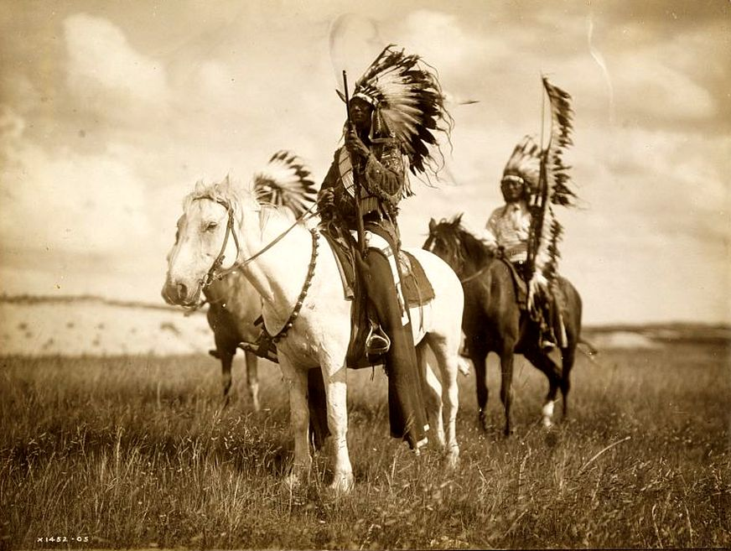
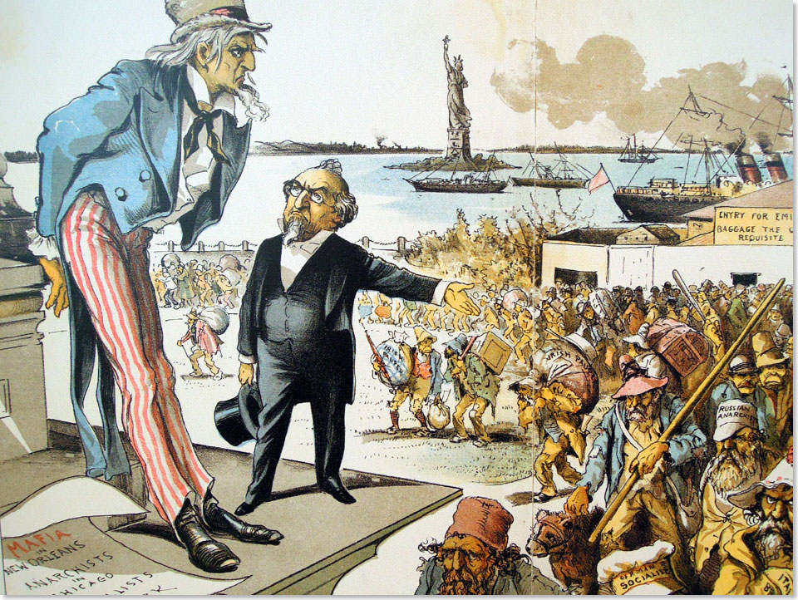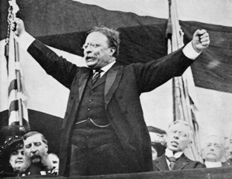

Mega Unit 1  The Great American West  The Gilded Age &  Progressivism | Week At A Glance #4  February 11-15

Date | Lesson Focus | Activities | Homework
February 11 | Gilded Age and The West Test
February 12 | Introduce Progressivism  - Umbrella of Progressivism  - Fixing the Problems of the Gilded Age  - Urban Issues | - Progressive Speed Dating Research | - Progressive Speed Dating  - Vocabulary
February 13 | Progressivism  - Finish Urban Issues  - Political Corruption and Abuse | - Progressive Speed Dating- Research and Writing | - Progressive Speed Dating  - Vocabulary
February 14 | Progressivism  - Robber Barons and Big Business | - Progressive Speed Dating- Research and Writing | - Progressive Speed Dating  - Vocabulary
February 15 | Speed Dating!  Early Release

Due on Monday February 15:

- Vocabulary
- Speed Dating assignments
  - Notes during speed dating
  - Resume

Index Card Vocab:

Front of Index Card Back of Index Card
Vocabulary Word | Internet Definition | Drawing of Vocab Term
 | Significance~ Why does it matter?

Level 1 Required Vocabulary ~ Required for all Students

Progressivism
- Muckraker
- 16th Amendment
- 17th Amendment
- 18th Amendment
- 19th Amendment
- Disenfranchise
- Plessy v Ferguson
- Conservation
- Preservation
- Social Gospel

