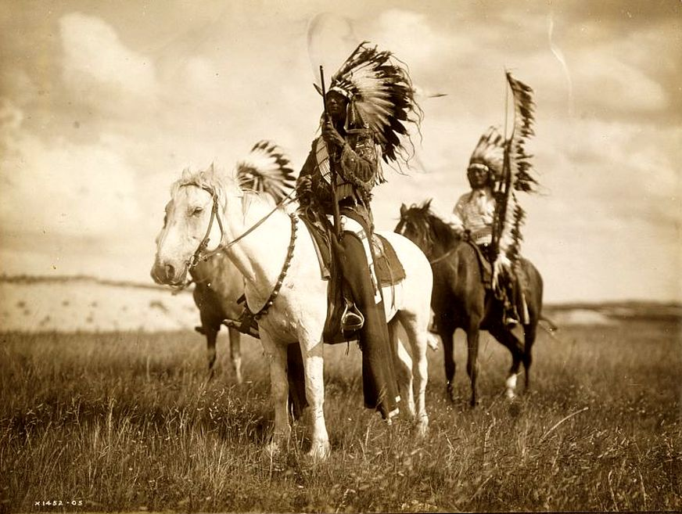
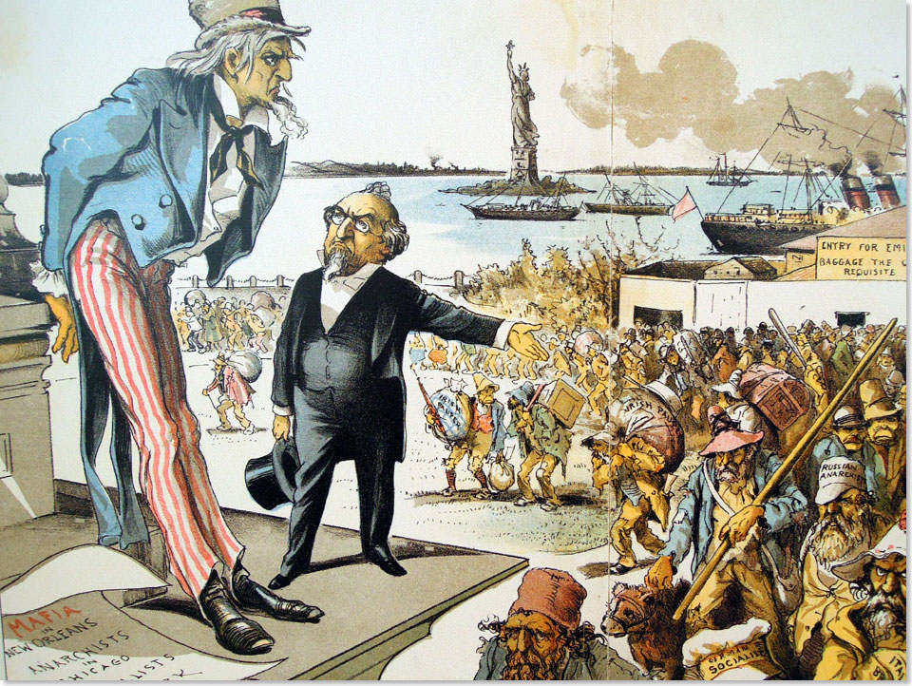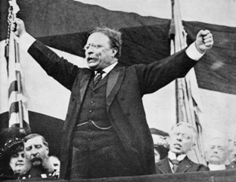

Mega Unit 1  The Great American West  The Gilded Age &  Progressivism | Week At A Glance #5  February 18-22  Last Week for Mega Unit #1

Date | Lesson Focus | Activities | Homework
February 18 | No School- President’s Day
February 19 | Progressive Speed Dating!  Short Class- 45 Minute Advisory Day | - Speed Dating | - Reflection Due on Monday February 25
February 20 | 1st Block- No Class Session  2nd Block- America the Story of Us- Cities  ACT Day |  | - Speed Date Reflection
February 21 | Progressivism  - Finish Working Conditions  - Race in the Progressive Era  Review for Common Writing Assessment | - The Jungle | - Speed Date Reflection
February 22 | Common Writing Assessment  Shaver out of the classroom |  | - Speed Date Reflection

Due on Monday February 25:

  - Speed Date Reflection

