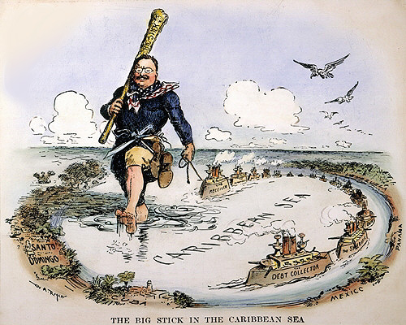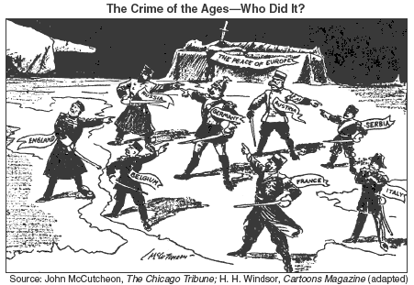
Mega Unit #2  1898-1945  American Foreign Policy: Imperialism, WWI and WWII | Week at a Glance #6  February 25- March 1

Date | Lesson Focus | Activities | Homework
February 25 | Introduce Imperialism  - Types of Imperialism and Reasons for Imperialism  American the Story of US- Cities | - America the Story of Us  - The Jungle- Jobs | Vocab  Fed-Ex: Imperialized Nations
February 26 | Finish Types of Imperialism  The Spanish American War  - Causes and Events of the War  - Outcomes of the Spanish American War  Fed-Ex Research | - FedEx Research- Examples of American Imperialism
February 27 | The Spanish American War  - Finish Outcomes of the War  Comparing Progressive and Imperial Presidencies  Finish FedEx Research | - FedEx Research- Examples of American Imperialism  - Comparing Presidencies
February 28 | - Finish Comparing Progressive and Imperial Presidencies  - Present FedEx Research  - The Causes of World War I  Introduce American Foreign Policy Map | - Present FedEx Research  - Foreign Policy Map
March 1 | World War I  - American Mobilization  - Troop Deployment  American Foreign Policy Map  4th Block Pep Rally | - Foreign Policy Map

Due on Friday March 1
- Vocabulary
- Openings
- FedEx Research
- Imperial President’s Graphic Organizer

Vocabulary ~ Required for all Students

Imperialism
- Spanish-American War
- Yellow Journalism
- USS Maine
- Rough Riders
- Big Stick Diplomacy
- Moral Diplomacy
- Dollar Diplomacy
- Great White Fleet
- Insular Cases
- Platt Amendment

Openings~ Feb 25-March 1

February 25 | Imperialism Preview
February 26
February 27
February 28
March 1

