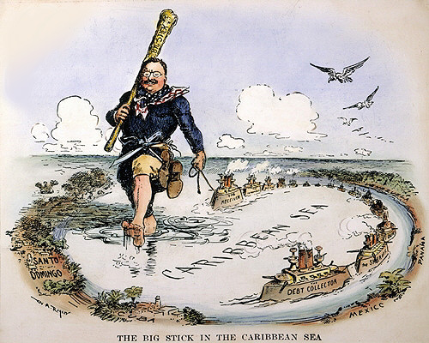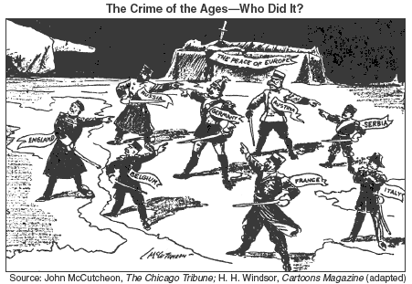
Mega Unit #2  1898-1945  American Foreign Policy: Imperialism, WWI and WWII | Week at a Glance #7  March 4-8

Date | Lesson Focus | Activities | Homework
March  4 | Intro to World War I | - American Foreign Policy Map | - Vocab  - Finish your own propaganda poster  - Finish Task 2 of Map
March  5 | Opening- Zimmerman Telegram  - War in Europe and the American Position  - American Mobilization for War | - Foreign Policy Map through Task 2  - Propaganda Activity
March  6 | Opening  - American Mobilization  - Woodrow Wilson’s 14 Points | - Propaganda Activity  - Wilson’s 14 Points Chunking Activity
March  7 | Opening  - Wilson’s 14 Points  - The Treaty of Versailles | - Comparing the 14 Points to the Treaty of Versailles
March  8 | Opening  - Finish Week’s Activities  - The Century Series- Shell Shock?  Early Release | - Finish work from week

Due on Friday March 8
- Vocabulary
- Openings
- 14 Points Primary Source Chunking Activity
- Treaty of Versailles (Maybe...)
- Propaganda Activity
- Personal propaganda poster

Vocabulary ~ Required for all Students

Imperialism
- Central Powers
- Allied Powers
- Unrestricted Submarine Warfare
- Lusitania
- Espionage Act
- Sedition Act
- Scheneck v United States
- League of Nations

Openings~ March 4-8

March 4 | Attach paper from class yesterday
March 5 | Zimmerman telegram- attach
March 6
March 7
March 8

